1. **Given the provided data, what are three conclusions we can draw about Kickstarter campaigns? And What are some other possible tables and/or graphs that we could create?**

* Based on the following stack chart we can conclude that in a big picture the projects with the Kickstarter are more successful than failed. Also, per the first graph if we analyze the results by main or parent category, it is notable that the Theater and Music categories have been running the most successful campaigns comparing Journalism, Game or Food.

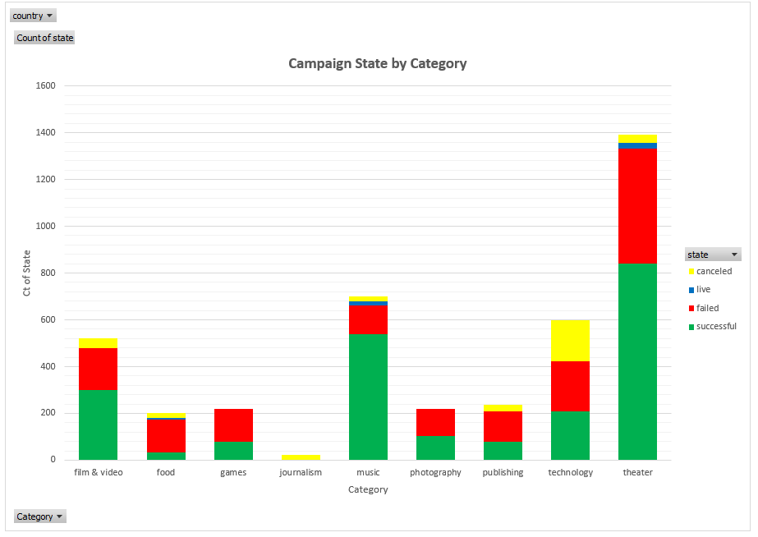

Also, by filtering this graph through the different countries and analyze them by the main category we can conclude that US out of all the countries runs the most successful and failed campaigns. Although Theater and Music categories are considered as the most successful parent category campaigns, but we can only assume this analysis for US since music category for GB has a very low success rate comparing to US. The data for the rest of the countries were so insignificant due to the small sample of data available, that we are won’t be able to draw any accurate conclusion in comparing them with result of US.

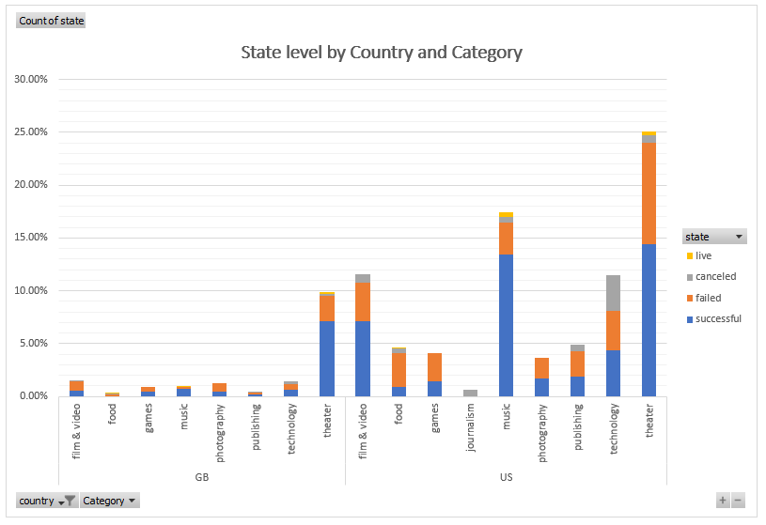

* Since the Live and Canceled status in the following graph are very insignificant, therefore we can focus more on analyzing the Successful and Failed campaigns. Also, we are planning to analyze the most successful campaign by parent category to see which sub category has the most success and failure campaigns. Based on our previous Analysis we mentioned that Theater, Music, Film & Video are our top three successful main categories. Per the Second stack chart which is filtered to only show us those two campaign states and those three parent categories, we can realize Plays in Theater, Documentary in Film & Video and finally Indie Rock in Music ran the most successful campaigns.

Moreover, despite of the fact that Animation in Film& Video and Jazz in music are the most failed campaigns, we can conclude that Plays in theater holds the most failed and most successful campaign in the Theater category.

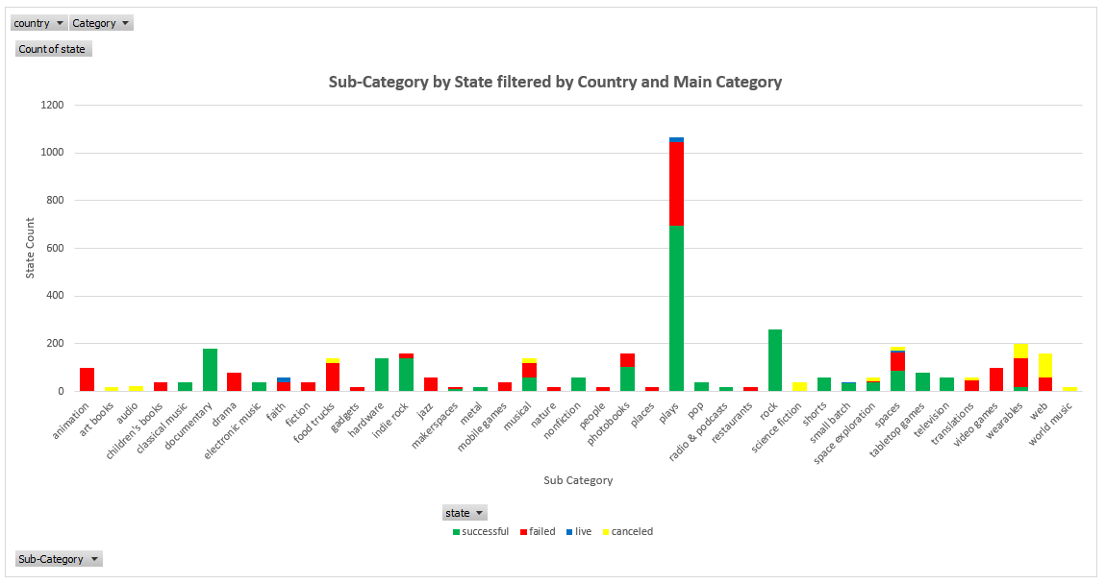

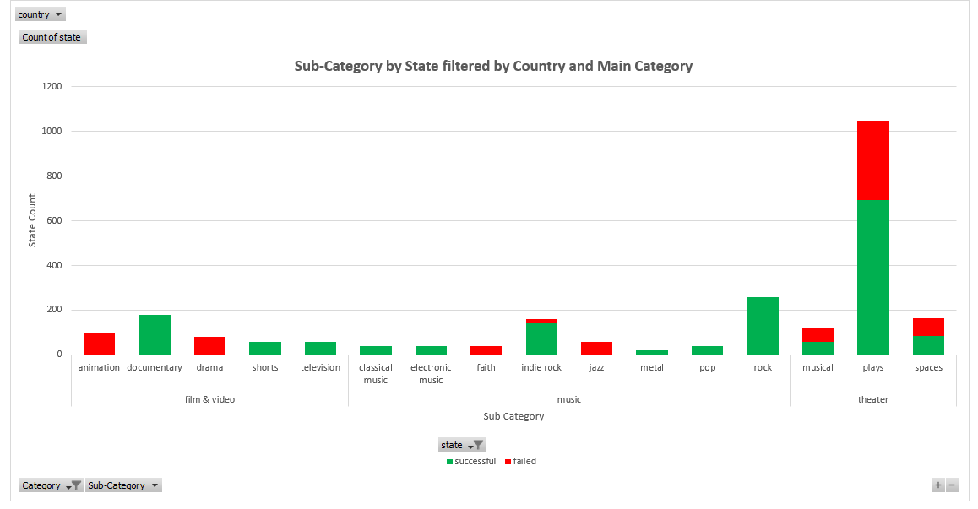

* The first Line graph indicates that beginning of May the successful campaigns started with some gradual decrease and by December we can see there is an overlap between the failed and successful campaigns. This means that by December the more successful some of our campaigns were within our parent and sub categories, others have started to fail.

Since this graph was only showing the months of the date created conversion, I have decided to slice this graph a bit more and review the data from the last three years. Therefore, by filtering the years to just show me the last three years, despite of the canceled campaigns our successful campaigns had a very unstable monthly change every year.

I would recommend reviewing the results from December of 2015 due to a very significant drop in our successful campaign and check what was the main reason behind it. Also, May of 2015 was the peak point in our successful campaigns. I would suggest going back to successful campaigns for these two months in 2015 and identify those parent and sub categories.

By reviewing the line graph for the Failed campaigns over the past year I wanted to suggest a very insignificant trend from Jan to Jul of each year. However, since the data for 2017 was not completed for all the 12 months, I have added 2014 data and the results were interesting. Adding this one year changed my hypothesis. From July to August of 2014 we have a drop for almost all our campaigns. I would recommend going back to those two months and review any possible changes in our ran campaigns.

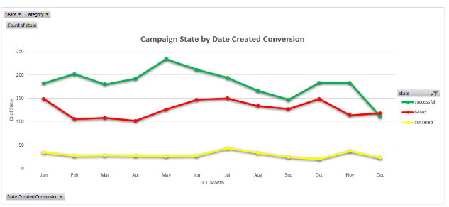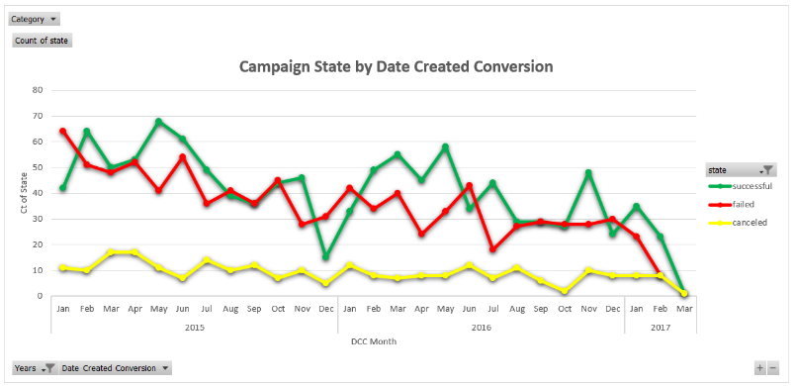

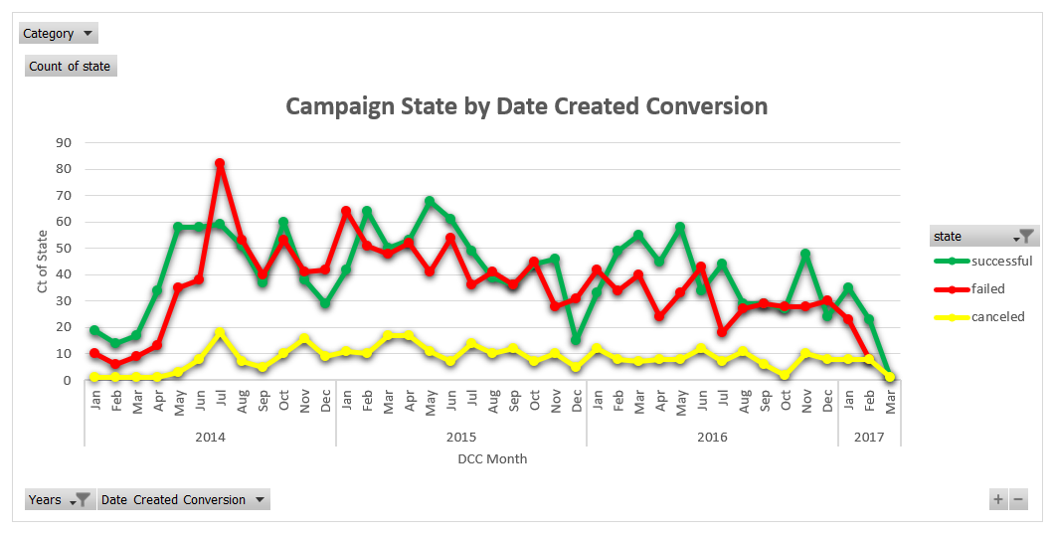

1. **What are some limitations of this dataset?**
2. One of the limitations of the data set to consider is the fact that the currency rate for each one of the available countries will be different and we will need to convert them to the USD $ to have a better understanding of the different states for our campaigns.

**Example:** Based on today’s rate the total of **$22345 NZD= $14306.39 USD** and the goal for this campaign was $20000 which has not been met. Therefore, considering this campaign as successful is not completely accurate.



1. Normally it is expected to assume that the total amount of pledges is related to number of backers. But we are forgetting the fact that if a backer has pledged a large amount this might affect the accuracy of our analysis. I expect the larger the total number of backers, the more pledges there are which is not true in all case for this data set.
2. It will be beneficial if we were able to analyze the available data by different states in each country and get more analysis in a more granular level. In that case we would have a better insight regarding the success level by state and we might find some trends if we review them by Date Created Conversion (Month) or even Parent category.
3. **What are some other possible tables and/or graphs that we could create?**

This question has been partially answered in the first part of this project. Also, my recommended graphs have been provided there as well.

Lastly, I would like to suggest analyzing the projects by the duration of conversion, by utilizing difference in days between the date created conversion and date ended conversion. Then we might be able to find any possible trends or outlier within the duration of successful/failed projects. Or we can run the correlation analysis to see if the duration between the date created and date ended have any relation to the state of the campaign.

